3.1 Troubleshooting device security using IOS AAA
(TACACS+, RADIUS, local database)

File | Location | Description
3.1 Troubleshoot device security using IOS AAA (TACACS+, RADIUS, local database).yaml | \ENARSI v1.1 Topics\3.0 Infrastructure Seurity\3.1 Troubleshoot device security using IOS AAA (TACACS+, RADIUS, local database) | YAML file. CML Topology file
Bash.sh | \ENARSI v1.1 Topics\3.0 Infrastructure Seurity\3.1 Troubleshoot device security using IOS AAA (TACACS+, RADIUS, local database)\Radius config files | Radius container startup script
Radius.conf | \ENARSI v1.1 Topics\3.0 Infrastructure Seurity\3.1 Troubleshoot device security using IOS AAA (TACACS+, RADIUS, local database)\Radius config files | Radius configuration
Users.conf | \ENARSI v1.1 Topics\3.0 Infrastructure Seurity\3.1 Troubleshoot device security using IOS AAA (TACACS+, RADIUS, local database)\Radius config files | Users on Radius server

Topology

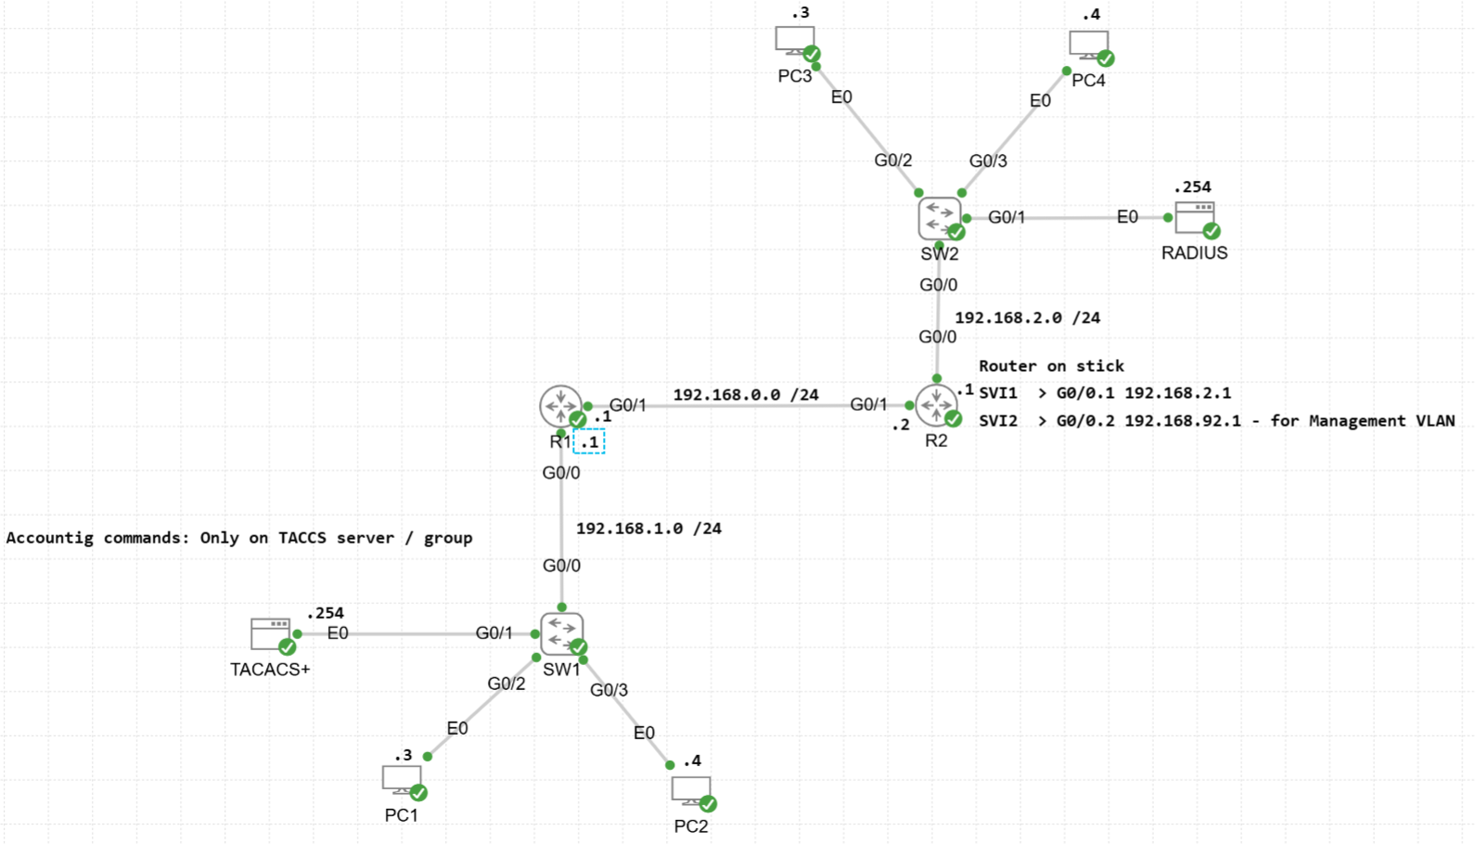

Files content

Bash.sh
# insert more commands here
ip address add dev eth0 192.168.2.254/24
ip link set dev eth0 up
ip route add default via 192.168.2.1 dev eth0
#
# keep the next line to indicate that the machine is ready
echo "READY" >/dev/console
exit 0

Radius.conf
# Basic freeRADIUS onfiguration
#
# This is what's included in the new container image for 2.9.1
# It's basically the stripped down version of the radiusd.conf that
# ships with the freeRADIUS distribution minus all the comments. Also:
# - no clients.conf dir inclusion (a wildcard client is defined below, note
# the shared secret)
# - a few more lines/sections have been commented out that were found to not
# be required for very basic RADIUS testing.
#
# NOTE it should be possible to successfully use this radiusd.conf with the
# container image that ships with CML 2.9.0

prefix = /usr
exec_prefix = /usr
sysconfdir = /etc
localstatedir = /var
sbindir = ${exec_prefix}/sbin
logdir = /var/log/freeradius
raddbdir = /etc/freeradius/3.0
radacctdir = ${logdir}/radacct
name = freeradius
confdir = ${raddbdir}
modconfdir = ${confdir}/mods-config
certdir = ${confdir}/certs
cadir = ${confdir}/certs
run_dir = ${localstatedir}/run/${name}
db_dir = ${raddbdir}
libdir = /usr/lib/freeradius
pidfile = ${run_dir}/${name}.pid
max_request_time = 30
cleanup_delay = 5
max_requests = 16384
hostname_lookups = no

log {
destination = syslog
colourise = yes
file = ${logdir}/radius.log
syslog_facility = daemon
stripped_names = no
auth = yes
auth_reject = yes
auth_badpass = yes
auth_goodpass = yes
msg_denied = "You are already logged in - access denied"
}

checkrad = ${sbindir}/checkrad

#ENV {
#}

security {
user = freerad
group = freerad
allow_core_dumps = no
max_attributes = 200
reject_delay = 1
status_server = yes
}

proxy_requests = no
#$INCLUDE proxy.conf

#$INCLUDE clients.conf
client all-devices {
ipaddr = *
secret = RadiusPwd
require_message_authenticator = no
nas_type = cisco
}

thread pool {
start_servers = 5
max_servers = 32
min_spare_servers = 3
max_spare_servers = 10
max_requests_per_server = 0
auto_limit_acct = no
}

modules {
$INCLUDE mods-enabled/
}

#instantiate {
#}

policy {
$INCLUDE policy.d/
}

$INCLUDE sites-enabled/

Users.conf

george Cleartext-Password := "geopwd"
Reply-Message = "Welcome, George!",
cisco-avpair = "shell:priv-lvl=15"

testuser Cleartext-Password := "testpassword"
Reply-Message = "Welcome, Test user",
cisco-avpair = "shell:priv-lvl=15"

pui Cleartext-Password := "puipwd"
Reply-Message = "Welcome, Pui!",
cisco-avpair = "shell:priv-lvl=15"

Node adaptations

On PCs – for ssh connection
Add this to etc/ssh/ssh_config

Host *
KexAlgorithms +diffie-hellman-group14-sha1,diffie-hellman-group-exchange-sha1
HostKeyAlgorithms +ssh-rsa

Output files – use tail commands to see live updates

On Radius check these files:
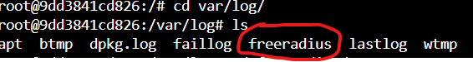
On Tacacs+ check these files:

Tac_plus.log
Tacplus-acct.log

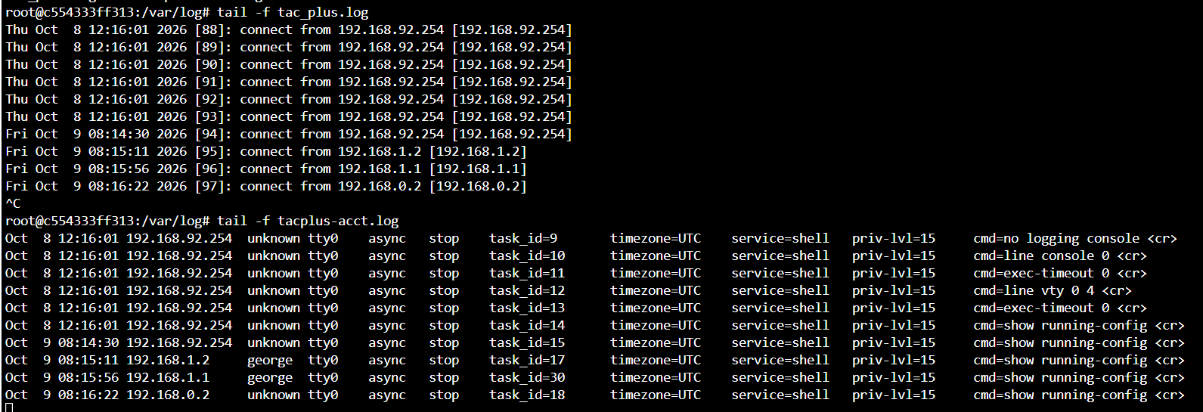

Useful show / debug commands

debug tacacs
debug radius
debug aaa authentication
debug aaa authorization
debug aaa accouting

show tacacs public
show radius statistics

Output example

R2(config)#router eigrp 1
R2(config-router)#
*Oct 7 03:03:12.849: AAA/ACCT/3844(00000010): Pick method list 'T_ACCT_COMMANDS'
*Oct 7 03:03:12.849: AAA/ACCT/SETMLIST(00000010): Handle 6E000010, mlist 0E879058, Name T_ACCT_COMMANDS
*Oct 7 03:03:12.849: Getting session id for CMD(00000010) : db=D072908
*Oct 7 03:03:12.849: AAA/ACCT/CMD(00000010): add, count 3
*Oct 7 03:03:12.849: AAA/ACCT/EVENT/(00000010): COMMAND
*Oct 7 03:03:12.851: AAA/ACCT/CMD(00000010): Queueing record is COMMAND osr 1
*Oct 7 03:03:12.851: AAA/ACCT/CMD(00000010): free_rec, count 2
*Oct 7 03:03:12.851: AAA/ACCT/CMD(00000010): Setting session id 30 : db=D072908
*Oct 7 03:03:12.860: AAA/ACCT(00000010): Accounting method=TACACS_GROUP (TACACS+)
*Oct 7 03:03:12.860: TPLUS: Queuing AAA Accounting request 16 for processing
*Oct 7 03:03:12.864: TPLUS: processing accounting request id 16
*Oct 7 03:03:12.864: TPLUS: Sending AV task_id=29
*Oct 7 03:03:12.864: TPLUS: Sending AV timezone=UTC
*Oct 7 03:03:12.864: TPLUS: Sending AV service=shell
*Oct 7 03:03:12.864: TPLUS: Sending AV priv-lvl=15
*Oct 7 03:03:12.864: TPLUS: Sending AV cmd=router eigrp 1 <cr>
*Oct 7 03:03:12.864: TPLUS: Accounting request created for 16(george)
*Oct 7 03:03:12.864: TPLUS: using previously set server 192.168.1.254 from group TACACS_GROUP
*Oct 7 03:03:12.866: TPLUS(00000010)/0/NB_WAIT/D084EF0: Started 5 sec timeout
*Oct 7 03:03:12.871: TPLUS(00000010)/0/NB_WAIT: socket event 2
*Oct 7 03:03:12.872: TPLUS(00000010)/0/NB_WAIT: wrote entire 110 bytes request
*Oct 7 03:03:12.872: TPLUS(00000010)/0/READ: socket event 1
*Oct 7 03:03:12.872: TPLUS(00000010)/0/READ: Would block while reading
*Oct 7 03:03:12.876: TPLUS(00000010)/0/READ: socket event 1
*Oct 7 03:03:12.877: TPLUS(00000010)/0/READ: read entire 12 header bytes (expect 5 bytes data)
*Oct 7 03:03:12.877: TPLUS(00000010)/0/READ: socket event 1
*Oct 7 03:03:12.877: TPLUS(00000010)/0/READ: read entire 17 bytes response
*Oct 7 03:03:12.877: TPLUS(00000010)/0/D084EF0: Proces
R2(config-routsing the reply packet
*Oct 7 03:03:12.877: TPLUS: Received accounting response with status PASS
*Oct 7 03:03:12.878: AAA/ACCT/CMD(00000010): STOP protocol reply PASS
*Oct 7 03:03:12.878: AAA/ACCT(00000010): Accounting response status = SUCCESS
*Oct 7 03:03:12.878: AAA/ACCT(00000010): Send STOP accounting notification to EM successfully
*Oct 7 03:03:12.878: AAA/ACCT/CMD(00000010): Cleaning up from Callback osr 0
*Oct 7 03:03:12.879: AAA/ACCT/CMD(00000010) Record not present
*Oct 7 03:03:12.879: /AAA/ACCTCMD(00000010) reccnt 2, csr FALSE, osr 0er)#
R2(config-router)#no router eigrp 1
R2(config)#
*Oct 7 03:03:39.639: AAA/ACCT/3844(00000010): Pick method list 'T_ACCT_COMMANDS'
*Oct 7 03:03:39.640: AAA/ACCT/SETMLIST(00000010): Handle 6E000010, mlist 0E879058, Name T_ACCT_COMMANDS
*Oct 7 03:03:39.640: Getting session id for CMD(00000010) : db=D072908
*Oct 7 03:03:39.640: AAA/ACCT/CMD(00000010): add, count 3
*Oct 7 03:03:39.640: AAA/ACCT/EVENT/(00000010): COMMAND
*Oct 7 03:03:39.641: AAA/ACCT/CMD(00000010): Queueing record is COMMAND osr 1
*Oct 7 03:03:39.642: AAA/ACCT/CMD(00000010): free_rec, count 2
*Oct 7 03:03:39.642: AAA/ACCT/CMD(00000010): Setting session id 31 : db=D072908
*Oct 7 03:03:39.644: AAA/ACCT(00000010): Accounting method=TACACS_GROUP (TACACS+)
*Oct 7 03:03:39.645: TPLUS: Queuing AAA Accounting request 16 for processing
*Oct 7 03:03:39.646: TPLUS: processing accounting request id 16
*Oct 7 03:03:39.646: TPLUS: Sending AV task_id=30
*Oct 7 03:03:39.647: TPLUS: Sending AV timezone=UTC
*Oct 7 03:03:39.647: TPLUS: Sending AV service=shell
*Oct 7 03:03:39.647: TPLUS: Sending AV priv-lvl=15
*Oct 7 03:03:39.647: TPLUS: Sending AV cmd=no router eigrp 1 <cr>
*Oct 7 03:03:39.647: TPLUS: Accounting request created for 16(george)
*Oct 7 03:03:39.647: TPLUS: using previously set server 192.168.1.254 from group TACACS_GROUP
*Oct 7 03:03:39.649: TPLUS(00000010)/0/NB_WAIT/10FB54B8: Started 5 sec timeout
*Oct 7 03:03:39.652: TPLUS(00000010)/0/NB_WAIT: socket event 2
*Oct 7 03:03:39.653: TPLUS(00000010)/0/NB_WAIT: wrote entire 113 bytes request
*Oct 7 03:03:39.653: TPLUS(00000010)/0/READ: socket event 1
*Oct 7 03:03:39.653: TPLUS(00000010)/0/READ: Would block while reading
*Oct 7 03:03:39.657: TPLUS(00000010)/0/READ: socket event 1
*Oct 7 03:03:39.658: TPLUS(00000010)/0/READ: read entire 12 header bytes (expect 5 bytes data)
*Oct 7 03:03:39.658: TPLUS(00000010)/0/READ: socket event 1
*Oct 7 03:03:39.658: TPLUS(00000010)/0/READ: read entire 17 bytes response
*Oct 7 03:03:39.658: TPLUS(00000010)/0/10FB54B8: P
R2(config)#rocessing the reply packet
*Oct 7 03:03:39.658: TPLUS: Received accounting response with status PASS
*Oct 7 03:03:39.659: AAA/ACCT/CMD(00000010): STOP protocol reply PASS
*Oct 7 03:03:39.659: AAA/ACCT(00000010): Accounting response status = SUCCESS
*Oct 7 03:03:39.659: AAA/ACCT(00000010): Send STOP accounting notification to EM successfully
*Oct 7 03:03:39.660: AAA/ACCT/CMD(00000010): Cleaning up from Callback osr 0
*Oct 7 03:03:39.660: AAA/ACCT/CMD(00000010) Record not present
*Oct 7 03:03:39.660: /AAA/ACCTCMD(00000010) reccnt 2, csr FALSE, osr 0

Log file

root@c554333ff313:/var/log# tail -f 50 tacplus-acct.log
tail: cannot open '50' for reading: No such file or directory
==> tacplus-acct.log <==
Oct 9 08:35:45 192.168.92.254 unknown tty0 async stop task_id=17 timezone=UTC service=shell priv-lvl=15 cmd=debug tacacs <cr>
Oct 9 08:35:51 192.168.92.254 unknown tty0 async stop task_id=18 timezone=UTC service=shell priv-lvl=15 cmd=configure terminal <cr>
Oct 9 08:35:59 192.168.92.254 unknown tty0 async stop task_id=19 timezone=UTC service=shell priv-lvl=15 cmd=logging console <cr>
Oct 9 08:53:34 192.168.0.2 george tty578 192.168.1.3 stop task_id=24 timezone=UTC service=shell priv-lvl=15 cmd=show running-config <cr>
Oct 9 08:55:22 192.168.1.2 george tty0 async stop task_id=22 timezone=UTC service=shell priv-lvl=15 cmd=do-exec sh ip int brief <cr>
Oct 9 08:55:45 192.168.92.254 unknown tty0 async stop task_id=20 timezone=UTC service=shell priv-lvl=15 cmd=do-exec sh ip int brief <cr>
Oct 9 08:57:35 192.168.0.2 george tty0 async start task_id=26 timezone=UTC service=shell
Oct 9 08:58:18 192.168.0.2 george tty0 async stop task_id=26 timezone=UTC service=shell priv-lvl=15 cmd=debug aaa accounting <cr>
Oct 9 08:59:09 192.168.0.2 george tty0 async stop task_id=27 timezone=UTC service=shell priv-lvl=15 cmd=debug aaa authentication <cr>
Oct 9 09:07:08 192.168.0.2 george tty0 async stop task_id=28 timezone=UTC service=shell priv-lvl=15 cmd=configure terminal <cr>
Oct 9 09:08:27 192.168.0.2 george tty0 async stop task_id=29 timezone=UTC service=shell priv-lvl=15 cmd=router eigrp 1 <cr>
Oct 9 09:08:54 192.168.0.2 george tty0 async stop task_id=30 timezone=UTC service=shell priv-lvl=15 cmd=no router eigrp 1 <cr>
After applying these configurations just shut down servers and check AAA behaaviour

0. aaa authentication login default local
1. aaa authentication login T_LOGIN_ONLY group TACACS_GROUP local
2. aaa authentication login R_LOGIN_ONLY group RADIUS_GROUP local
3. aaa authentication login R_T_LOGIN group RADIUS_GROUP group TACACS_GROUP local
4. aaa authentication login T_R_LOGIN group TACACS_GROUP group RADIUS _GROUP local
5. aaa authorization exec R_EXEC_ONLY group RADIUS_GROUP local
6. aaa authorization exec T_EXEC_ONLY group TACACS_GROUP local
7. aaa authorization exec R_T_EXEC group RADIUS_GROUP group TACACS_GROUP local
8. aaa authorization exec T_R_EXEC group TACACS_GROUP group RADIUS_GROUP local
9. aaa accounting exec R_ACCT_ONLY start-stop group RADIUS_GROUP
10. aaa accounting exec T_ACCT_ONLY start-stop group TACACS_GROUP
11. aaa accounting exec R_T_ACCT start-stop group RADIUS_GROUP group TACACS_GROUP
12. aaa accounting exec T_R_ACCT start-stop group TACACS_GROUP group RADIUS_GROUP
13. aaa accounting command 15 T_ACCT start-stop group TACACS_GROUP

 |  | R1 | R2 | SW1 | SW2
Line console 0 | LOGIN | 1 | 4 | 3 | 2
Line console 0 | AUTHORIZATION | 6 | 8 | 7 | 5
Line console 0 | ACCOUNTING EXE | 10 | 12 | 11 | 9
Line console 0 | ACCOUTING COMMAND | 13 | 13 | 13 | 13
Line vty 0 4 | LOGIN | 2 | 3 | 4 | 1
Line vty 0 4 | AUTHORIZATION | 5 | 7 | 8 | 6
Line vty 0 4 | ACCOUNTING EXE | 9 | 11 | 12 | 10
Line vty 0 4 | ACCOUTING COMMAND | 13 | 13 | 13 | 13

Compatibility matrix
AAA Operation | Console | VTY lines | Supported by TACACS*? | Supported by RADIUS?
Authentication (Login) | YES (Local / Server) | YES (Local / Server) | YES | YES
Authorization EXEC (Shell) | YES, recommended local/TACACS+ | YES (Server / Local) | YES (Nativ) | LIMITED (Fail often for console)
Authorization Commands | YES (only with TACACS+) | YES (only with TACACS+) | YES (Nativ per commmand) | NO ❌ (Does not know commands)
Accounting EXEC (Sessions) | YES | YES | YES | YES
Accounting Commands | YES (only with TACACS+) | YES (only with TACACS+) | YES (only with TACACS+) | NO ❌ (Does not know commands)

